Claims based - Disease Interaction for Member
RMO Table for 5 Members
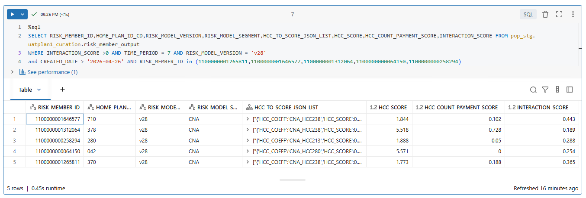

RMHCC Table for same 5 members (Before & After fix) – Full Result is in Excel.
